Movie Review Assignment 1 Instruction (Due March 4)

We will watch the first episode of a documentary “Unnatural Causes”. Please click the following link

https://www.njvid.net/show.php?pid=njcore:17839

You will see the following
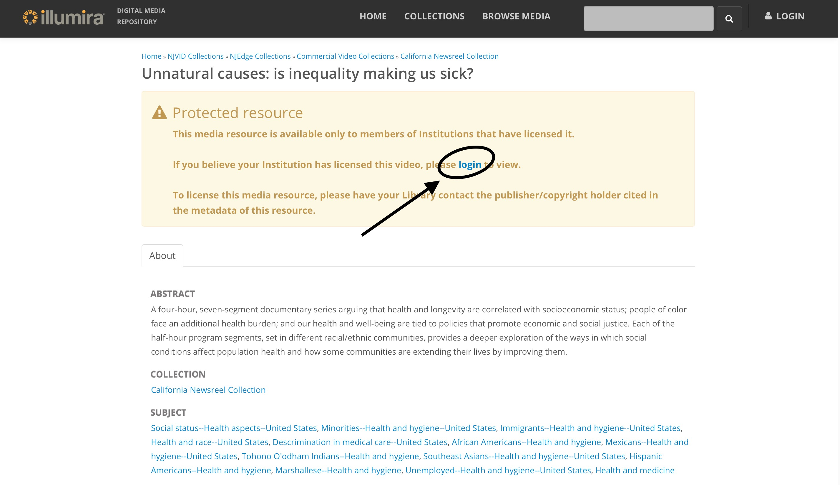

Click log in and select “Rutgers, The State University of New Jersey” from the pull down menu. Using your NetID and password to log in.

Watch the first episode (i.e., the first 55 minutes) but you are welcome to watch all episodes by yourself. I highly recommend this series.

Assignment

After you watch the first episode, please write a 1-2 pages (double space) summary of the movie. Please make sure you put your name and student ID when you turn in your assignment. In your summary, please describe

- What you learn from the movie?
- After watching this move, in your opinion, how does racism affect health?

